Logic Design Final Exam Rehearsal
2023. 05. 24.

1. 4-bit adder with four sources for one operand includes four three-state buffers. Redesign this adder with a MUX and without any 3-state buffer.
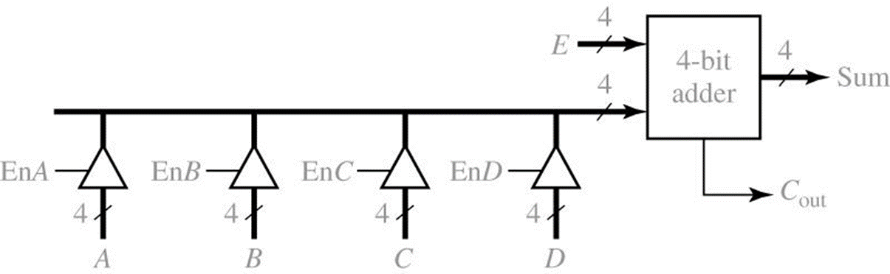
2. For SR, JK and T type flip-flops
a) Derive the characteristic and excitation equations
b) Convert a JK flip-flop to a T flip-flop.

3. Design an odd number counter (0, 1, 3, …, 9, 0) with SR type flip-flops. a) State graph
b) State table with flip-flop inputs
c) Karnaugh Map process for finding optimal logic equations
d) Gate level circuit

4. Compare the public transportation bus and the data transfer bus based on the figure.
a) Source-wise
a) Destination -wise
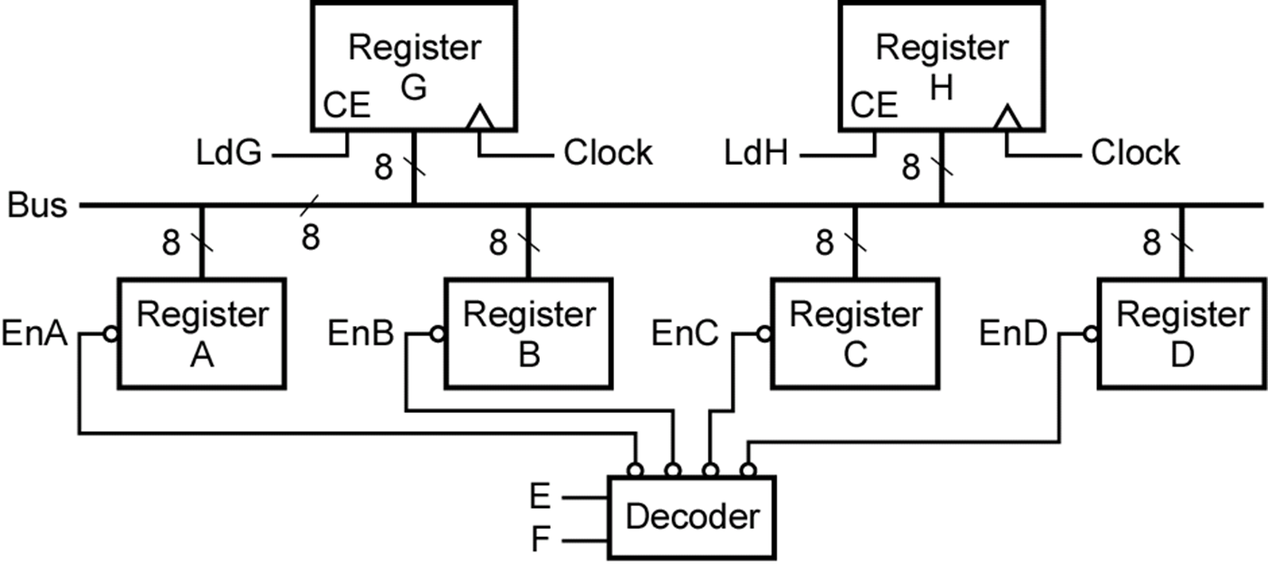
5. Design a Parity checker for every 1-byte period based on the given waveforms. (Software class)
a) State graph
b) State and transition tables with JK type flip-flops.
c) Karnaugh Map process for finding optimal logic equations
d) Gate level circuit

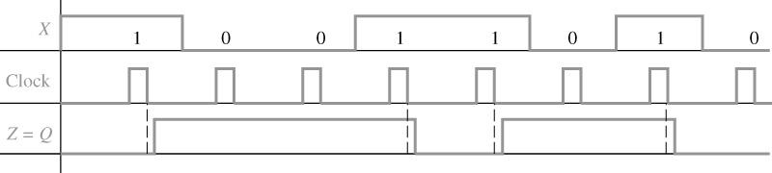

5. Design a Moore sequential circuit based on the given waveforms. (Semiconductor class)
a) State graph
b) State and transition tables with JK type flip-flops.
c) Karnaugh Map process for finding optimal logic equations
d) Gate level circuit

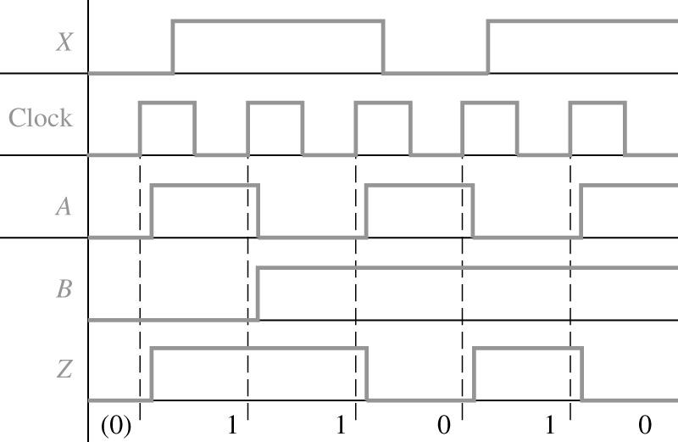

6. Design a Mealy type sequence detector for finding ‘010” OR “011” from a continuous sequential inputs with JK type flip-flops.
a) State graph
b) State and transition tables with JK type flip-flops.
c) Karnaugh Map process for finding optimal logic equations
d) Gate level circuit

